STEP-TO-STEP GUIDE ON BOOKING CAMP

STEP 1

Head over to our Book now page on our website! www.revolutionsoccercamps.com/book-online//
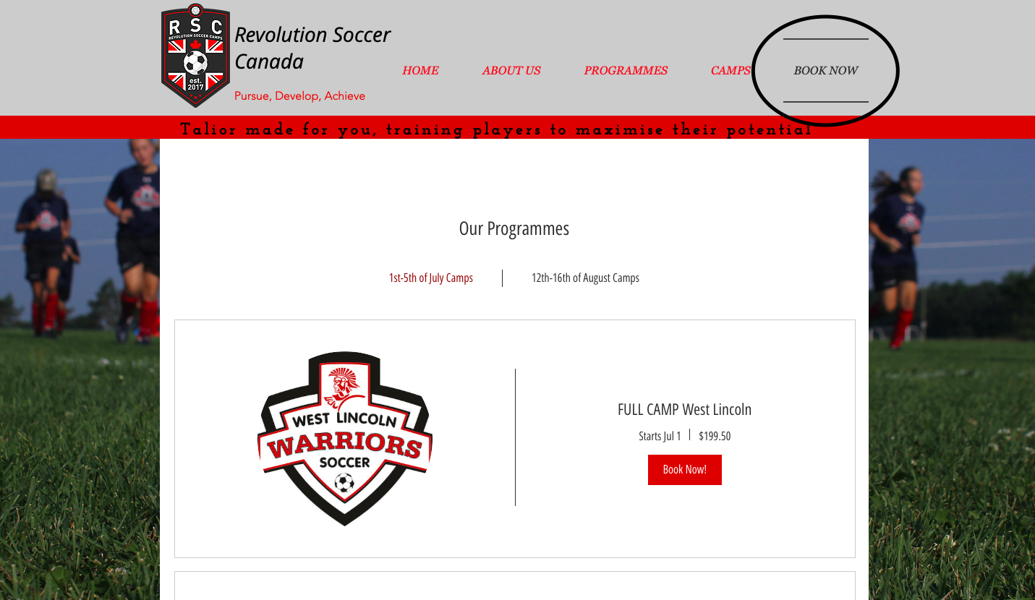

STEP 2

Scroll down to find a program near you…
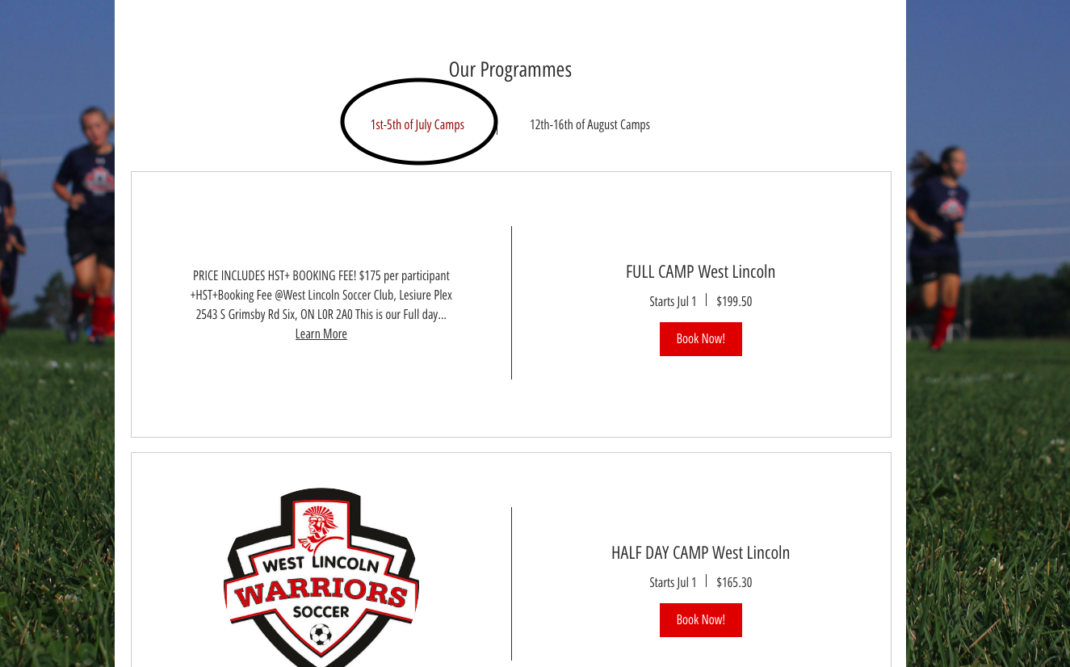

STEP 3

Click the book now icon to find more information on the camp of your choice…..
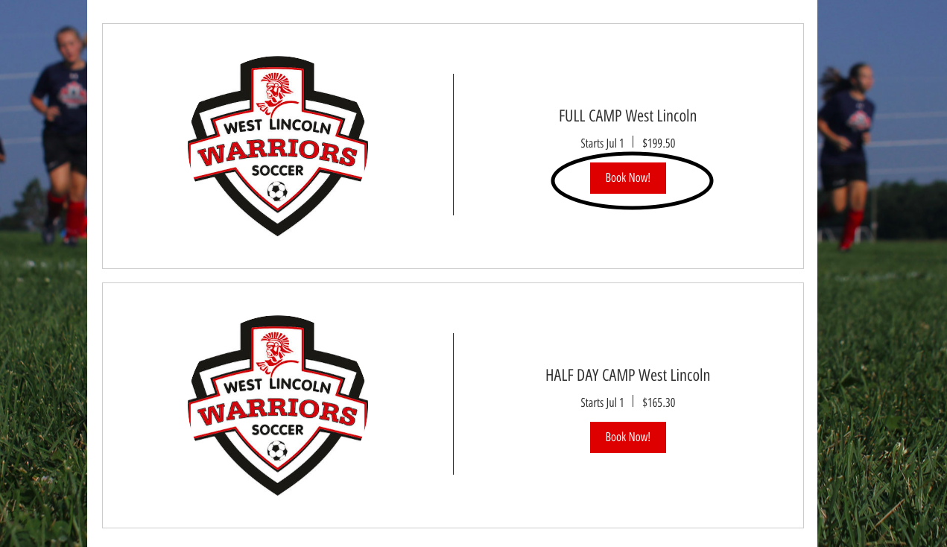
Make sure you click on the right program for you…..

STEP 4

If you are happy with your choice, scroll down to the book online and click book now to confirm camp.

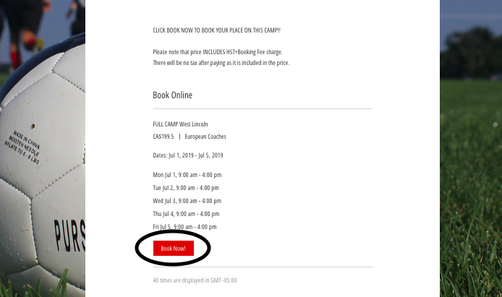

STEP 5

Once clicking book now, you will land on the confirm now page which you will need to fill out to confirm camp.

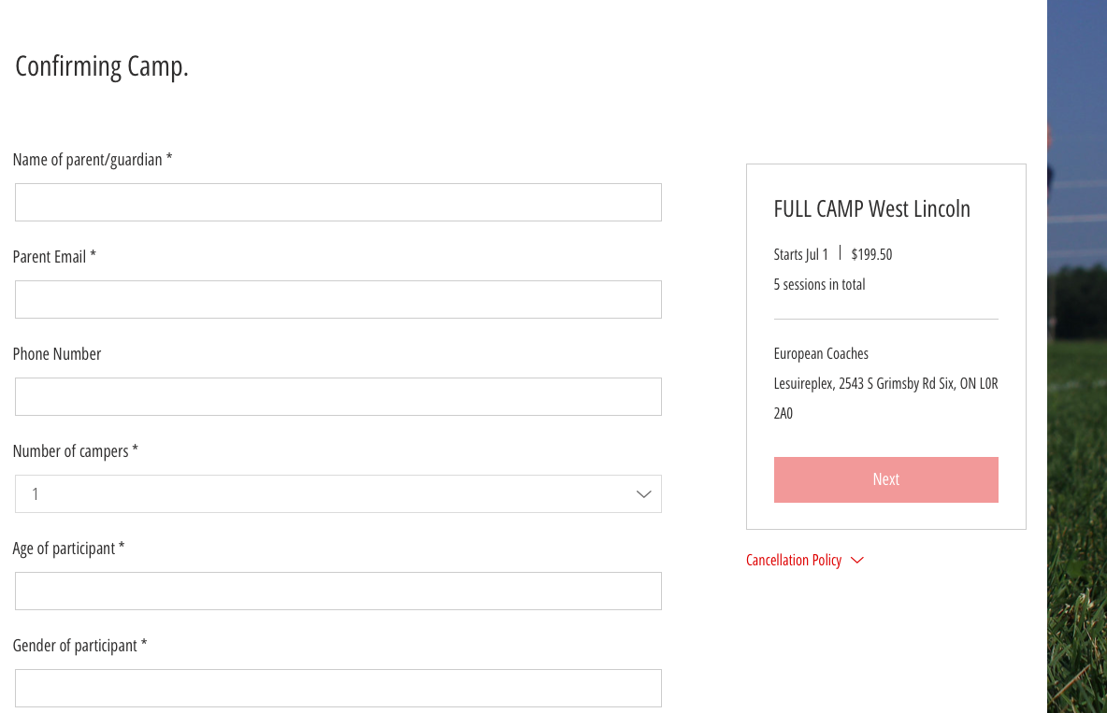

STEP 6

After filling out the details for your child/participant to join us on camp it will lead us to the payment area, in which you can pay by card or via pay pal.

If you wish to pay by cheque, please contact J.Clements@revolutionsoccercamps.com.

